**LAPORAN PROYEK 5**

**BOTTOM UP DATABASE DESAIN**

**PADA SISTEM INFORMASI (APLIKASI)**

**PERPUSTAKAAN**



**OLEH:**

**AHMADI MUSLIM**

**NISN. 91287491261**

**REKAYASA PERANGKAT LUNAK**

**SMK NEGERI 1 KARANG BARU**

**PEMERINTAH PROVINSI ACEH**

**2023**

**LAPORAN PRAKTIKUM BASIS DATA**

**Create, Read, Update, dan Delete (CRUD) / DDL, DML, DCL, TCL**

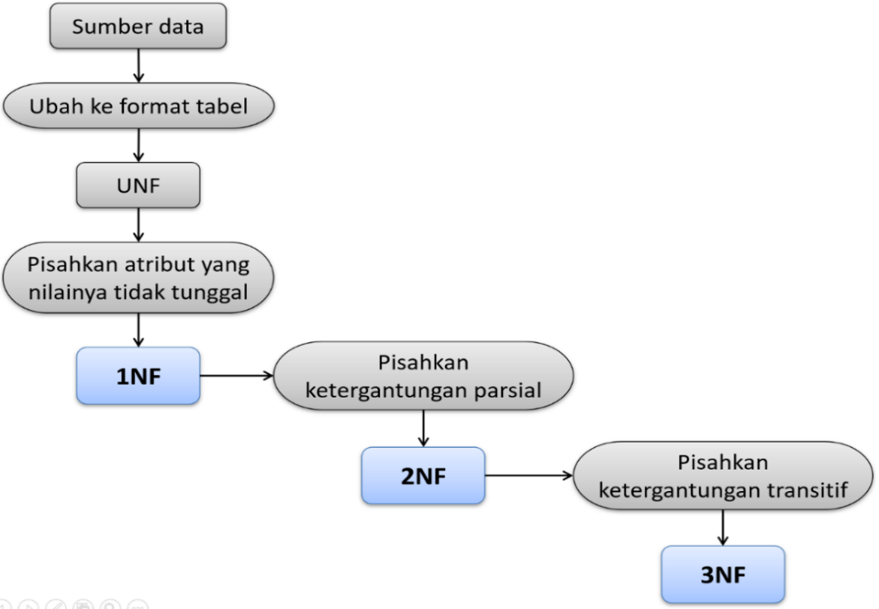



**Tugas…!  
Kerjakan Instruksi Berikut Ini .!**

1. Ekstraksi/konversi Tabel (unf)
2. Normalisasi Tabel

**1nf**

**2nf**

**3nf**

1. Membuat ER-Diagram
2. Membuat ER-Table
3. Membuat Source SQL

**Tabel anggota**

|  |  |  |  |  |  |
| --- | --- | --- | --- | --- | --- |
| **No** | **Nama kolom** | **Tipe data** | **Lebar** | **Null** | **kunci** |
| 1 |  |  |  |  |  |
| 2 |  |  |  |  |  |
| 3 |  |  |  |  |  |

**Tabel admin**

|  |  |  |  |  |  |
| --- | --- | --- | --- | --- | --- |
| **No** | **Nama kolom** | **Tipe data** | **Lebar** | **Null** | **kunci** |
| 1 |  |  |  |  |  |
| 2 |  |  |  |  |  |
| 3 |  |  |  |  |  |
| 4 |  |  |  |  |  |

**Tabel buku**

|  |  |  |  |  |  |
| --- | --- | --- | --- | --- | --- |
| **No** | **Nama kolom** | **Tipe data** | **Lebar** | **Null** | **kunci** |
| 1 |  |  |  |  |  |
| 2 |  |  |  |  |  |
| 3 |  |  |  |  |  |

**Tabel pinjam**

|  |  |  |  |  |  |
| --- | --- | --- | --- | --- | --- |
| **No** | **Nama kolom** | **Tipe data** | **Lebar** | **Null** | **kunci** |
| 1 |  |  |  |  |  |
| 2 |  |  |  |  |  |
| 3 |  |  |  |  |  |

**Tabel detilpinjam**

|  |  |  |  |  |  |
| --- | --- | --- | --- | --- | --- |
| **No** | **Nama kolom** | **Tipe data** | **Lebar** | **Null** | **kunci** |
| 1 |  |  |  |  |  |
| 2 |  |  |  |  |  |
| 3 |  |  |  |  |  |
|  |  |  |  |  |  |
|  |  |  |  |  |  |

1. Membuat Database Di Phpmysadmin Melalui SQL

**Tabel anggota**

**Tabel admin**

**Tabel buku**

**Tabel pinjam**

**Tabel detilpinjam**

1. Memposting ke PHPMyadmin (desain skema tabel)